**Mortgage Calculator**

The Mortgage Calculator application is used to provide right loan plan and provide details about interest and repayment of loan.This is web application which can be easily accessed to perform mortgage calculation and provide mortgages which are present to the end user.

Softwares used for this application:

* Visual Studio 2017
* MVC 5
* Web API 2
* Angular JS
* MsTest
* MOQ

Please find below details of application

**Home Page**

The Mortgage Calculator application is launched with Home Page which is used to contain menu to access mortgage calculation and to view active mortgages present.Please find below screenshot of application.

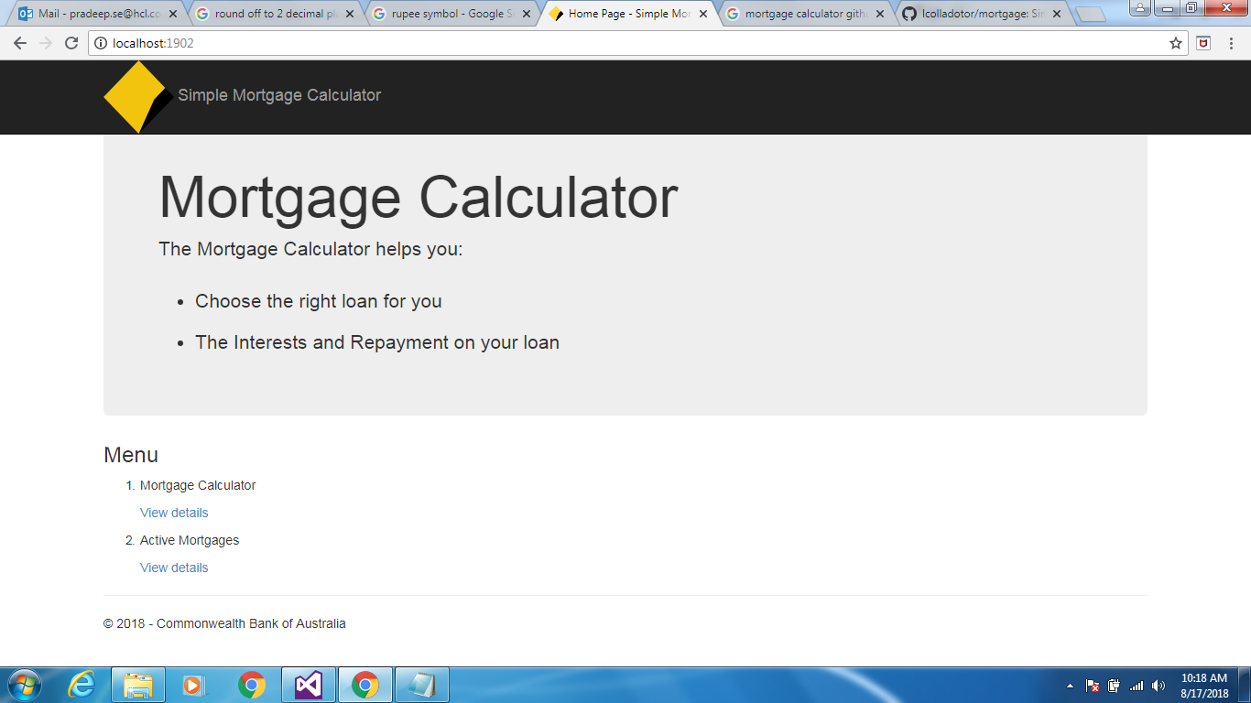

**Mortgage Calculator**

The user clicks on ‘View details’ link of Mortgage Calculator to access Mortgage Calculator page.

The user needs to provide input details like Loan Amount, Loan Duration Period (in terms of Years) and Interest Rate (in terms of Year).Once user submits the details based on the inputs calculator is used to perform calculation and provide output of Total repayment over the lifetime of the loan, Amount paid in interest over the life of the loan.Please find the screenshot given below.

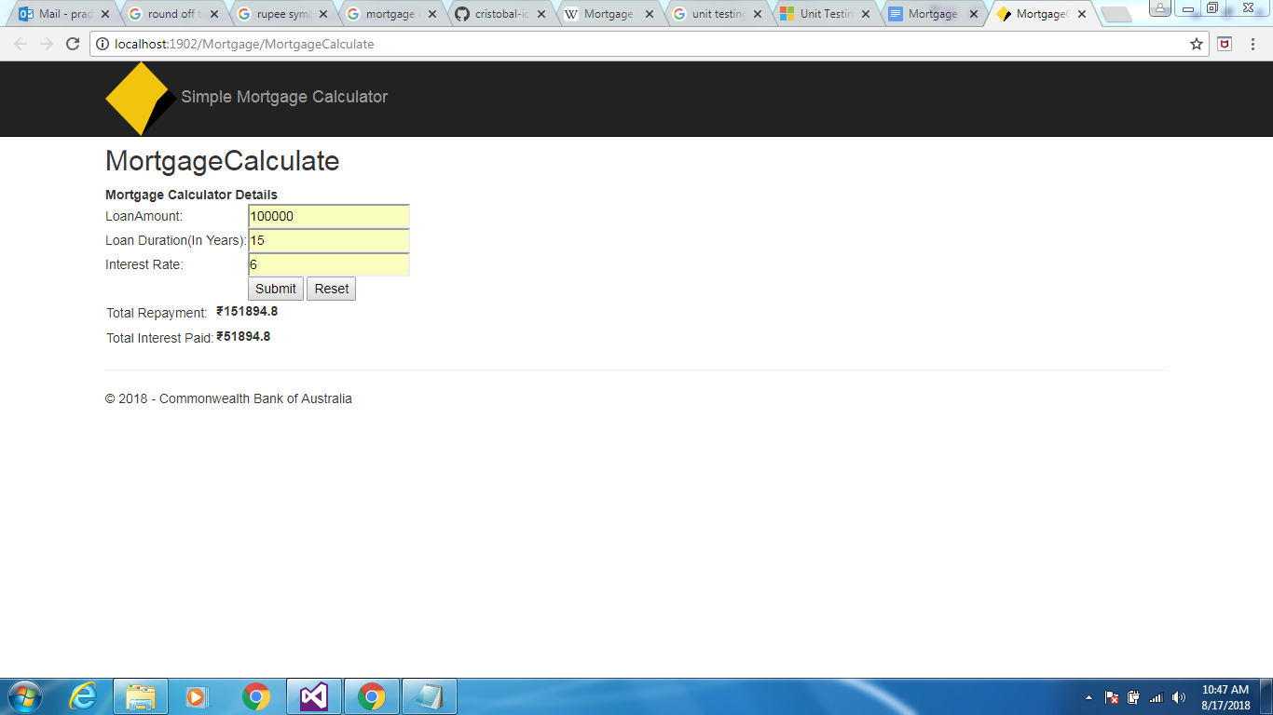

**Active Mortgages**

The user clicks on ‘View Details’ link on Active Mortgages to access Active Mortgages page.

The Active Mortgages details are displayed in the grid used to display details of Mortgages like Mortgage ID, Name, Mortgage Type, Interest Rate, Effective Start Date, Effective End Date, Term(in terms of Months), Cancellation Fee, Establishment Fee and Schema Identifier.The grid is provided with features like Sorting, Selection and Hiding.The user can able to view all active mortgage details and perform operations.Please find screenshot given below.

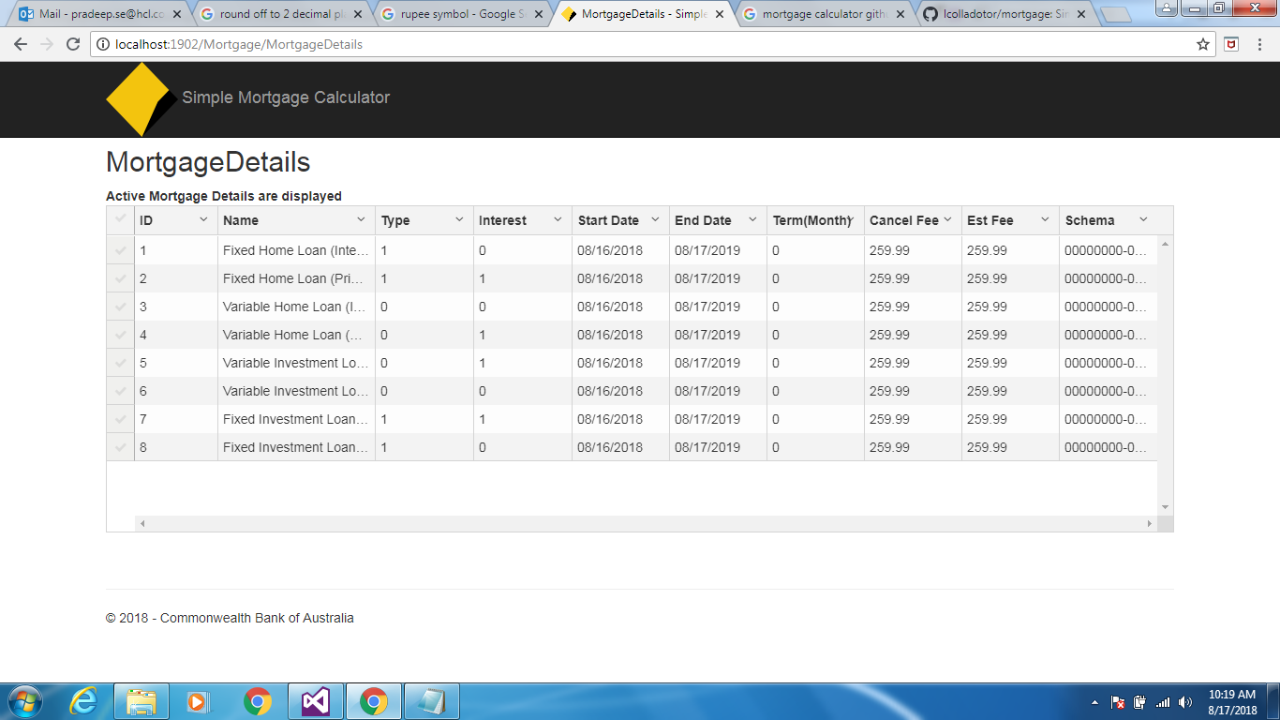

**Active Mortgages Sorting**

The Active Mortgages grid is used to perform Sorting for multiple columns.The result will be provided with order of sorting with numeric position.

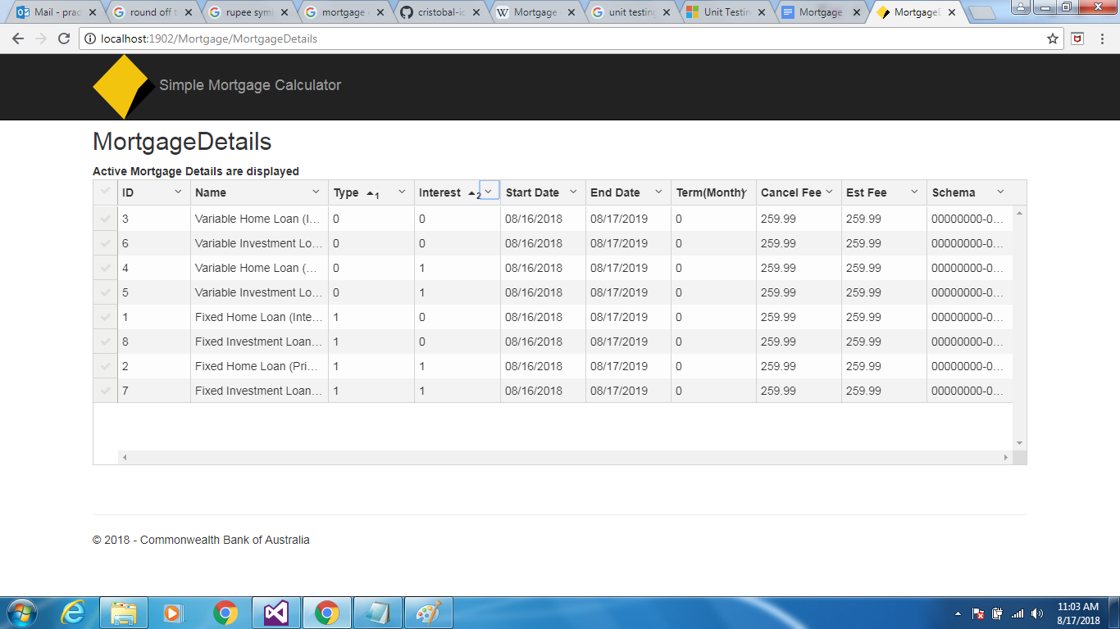

**Active Mortgage Features**

Please find below screenshot contains features of grid.

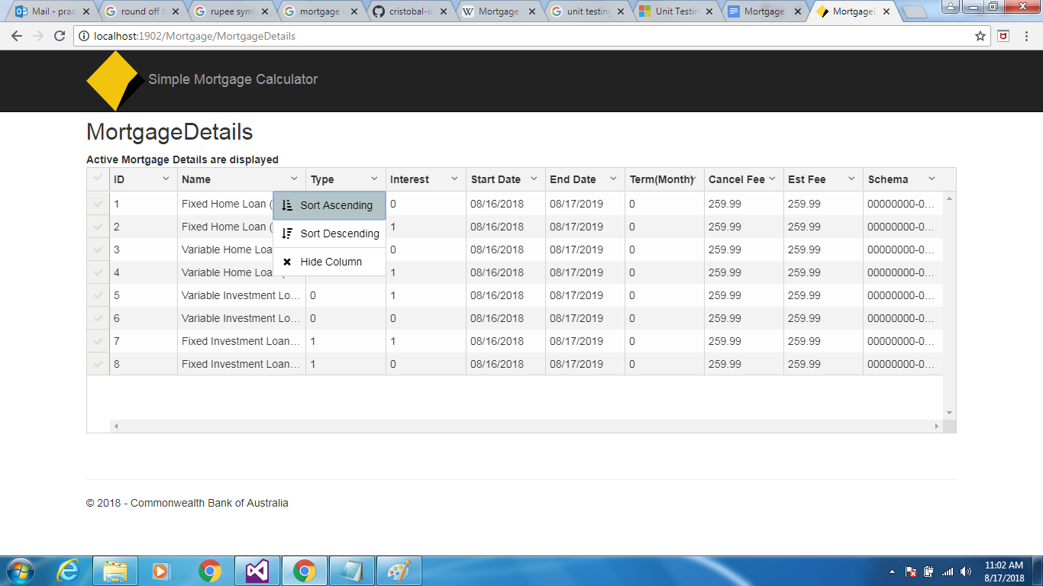

**Active Mortgages Selection:**

The Active Mortgage grid is used to perform selection of row and selected row will be retrieved individually.User have to select row by selecting on that row.Please find the screenshot given below.

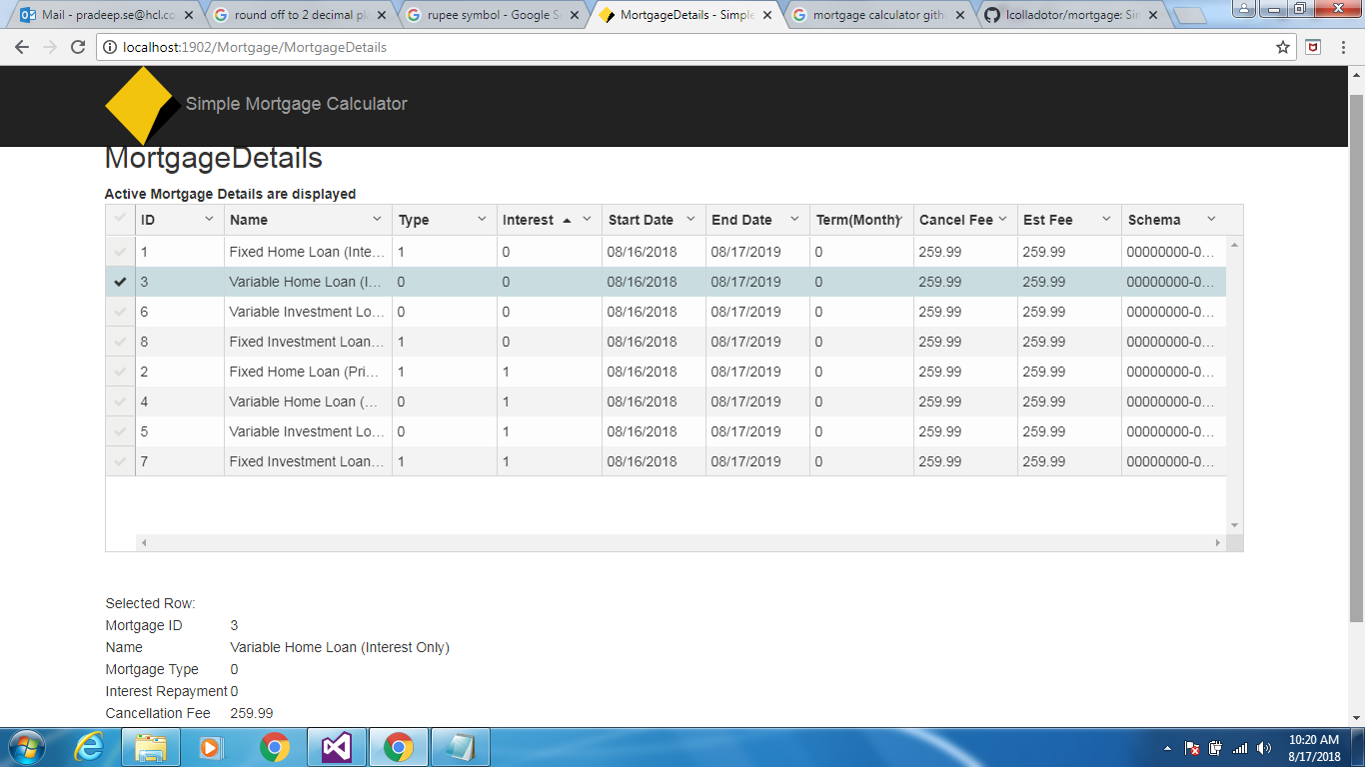

Unit Test Coverage:

Have done unit test for Web and Web Api project.Please find screenshot given below.

